UNITED STATES
SECURITIES AND EXCHANGE COMMISSION
Washington, D.C. 20549

FORM 8-K

CURRENT REPORT
Pursuant to Section 13 or 15(d) of the Securities Exchange Act of 1934

Date of Report (Date of earliest event reported): September 22, 2026

SILVIA, INC.
(Exact name of registrant as specified in its charter)

Delaware |  | 001-42995 |  | 39-2767031
(State or other jurisdiction  of incorporation) |  | (Commission  File Number) |  | (IRS Employer  Identification No.)

600 Lexington Avenue, Floor 2
New York, New York 10022
(Address of principal executive offices) (Zip Code)

(305) 938-0912
(Registrant’s telephone number, including area code)

ProCap Financial, Inc.
(Former name or former address, if changed since last report)

Check the appropriate box below if the Form 8-K filing is intended to simultaneously satisfy the filing obligation of the registrant under any of the following provisions:

☐ | Written communications pursuant to Rule 425 under the Securities Act (17 CFR 230.425)
☐ | Soliciting material pursuant to Rule 14a-12 under the Exchange Act (17 CFR 240.14a-12)
☐ | Pre-commencement communications pursuant to Rule 14d-2(b) under the Exchange Act (17 CFR 240.14d-2(b))
☐ | Pre-commencement communications pursuant to Rule 13e-4(c) under the Exchange Act (17 CFR 240.13e-4(c))

Securities registered pursuant to Section 12(b) of the Act:

Title of each class |  | Trading Symbol(s) |  | Name of each exchange on which registered
Common Stock, par value $0.001 per share |  | SVIA |  | The Nasdaq Stock Market LLC
Redeemable warrants, each whole warrant exercisable for one share of Common Stock at an exercise price of $11.50 per share |  | SVIAW |  | The Nasdaq Stock Market LLC

Indicate by check mark whether the registrant is an emerging growth company as defined in Rule 405 of the Securities Act of 1933 (§ 230.405 of this chapter) or Rule 12b-2 of the Securities Exchange Act of 1934 (§ 240.12b-2 of this chapter).

Emerging growth company ☒

If an emerging growth company, indicate by check mark if the registrant has elected not to use the extended transition period for complying with any new or revised financial accounting standards provided pursuant to Section 13(a) of the Exchange Act. ☐

Item 5.03. Amendments to Articles of Incorporation or Bylaws; Change in Fiscal Year.

On September 17, 2026, ProCap Financial, Inc. (the “Company”) filed a Certificate of Amendment (the “Certificate of Amendment”) to its Amended and Restated Certificate of Incorporation (the “Certificate of Incorporation”) with the Secretary of State of the State of Delaware to change the Company’s corporate name from “ProCap Financial, Inc.” to “Silvia, Inc.” (the “Name Change”). The Certificate of Amendment became effective on September 22, 2026. The Name Change and Certificate of Amendment were approved by the Company’s Board of Directors (the “Board”) on September 2, 2026. Pursuant to Section 242(d)(1) of the Delaware General Corporation Law, approval of the Company’s stockholders was not required to effect the Name Change.

Other than the change to the Company’s name, the Certificate of Amendment did not amend any other provision of the Certificate of Incorporation.

In connection with the Name Change, the Board approved the Second Amended and Restated Bylaws of the Company (the “Second Amended and Restated Bylaws”), effective September 22, 2026, solely to reflect the Company’s new name. The Second Amended and Restated Bylaws made no other changes to the Company’s bylaws.

The Name Change does not affect the rights of the Company’s stockholders or warrant holders. The Company’s common stock and warrants trading on The Nasdaq Global Market (“Nasdaq”) under the symbols “BRR” and “BRRW”, respectively, began trading on Nasdaq under the symbols “SVIA” and “SVIAW”, respectively, effective as of September 22, 2026. Stockholders and warrant holders are not required to take any action; outstanding stock and warrant certificates are not affected by the Name Change and do not need to be exchanged.

The foregoing description does not purport to be complete and is qualified in its entirety by reference to the full text of the Certificate of Amendment and the Second Amended and Restated Bylaws, copies of which are filed as Exhibits 3.2 and 3.4, respectively, to this Current Report on Form 8-K and are incorporated herein by reference.

Item 7.01 Regulation FD Disclosure.

On September 22, 2026, the Company issued a press release announcing the Name Change. A copy of the press release is furnished as Exhibit 99.1 to this Current Report on Form 8-K.

The information furnished under this Item 7.01, including Exhibit 99.1, shall not be deemed “filed” for purposes of Section 18 of the Securities Exchange Act of 1934, as amended (the “Exchange Act”), or otherwise subject to the liabilities of that section, nor shall it be deemed incorporated by reference in any filing under the Securities Act or the Exchange Act, except as shall be expressly set forth by specific reference in such a filing.

Item 9.01. Financial Statements and Exhibits.

(d) Exhibits.

Exhibit Number |  | Description of Exhibit
3.1 |  | Amended and Restated Certificate of Incorporation of the Company.
3.2 |  | Certificate of Amendment to the Amended and Restated Certificate of Incorporation of the Company, filed with the Secretary of State of the State of Delaware on September 17, 2026.
3.3 |  | Amended and Restated By-Laws of the Company (incorporated by reference to Exhibit 3.2 to the Company’s Current Report on Form 8-K filed with the SEC on December 11, 2025).
3.4 |  | Second Amended and Restated Bylaws of the Company, effective September 22, 2026.
99.1 |  | Press Release, dated September 22, 2026.
104 |  | Cover Page Interactive Data File (embedded within the Inline XBRL document).

SIGNATURE

Pursuant to the requirements of the Securities Exchange Act of 1934, the registrant has duly caused this report to be signed on its behalf by the undersigned hereunto duly authorized.

 | SILVIA, INC.
Date: September 22, 2026 | By: | /s/ Anthony Pompliano
 | Name: | Anthony Pompliano
 | Title: | Chief Executive Officer

Exhibit 3.1

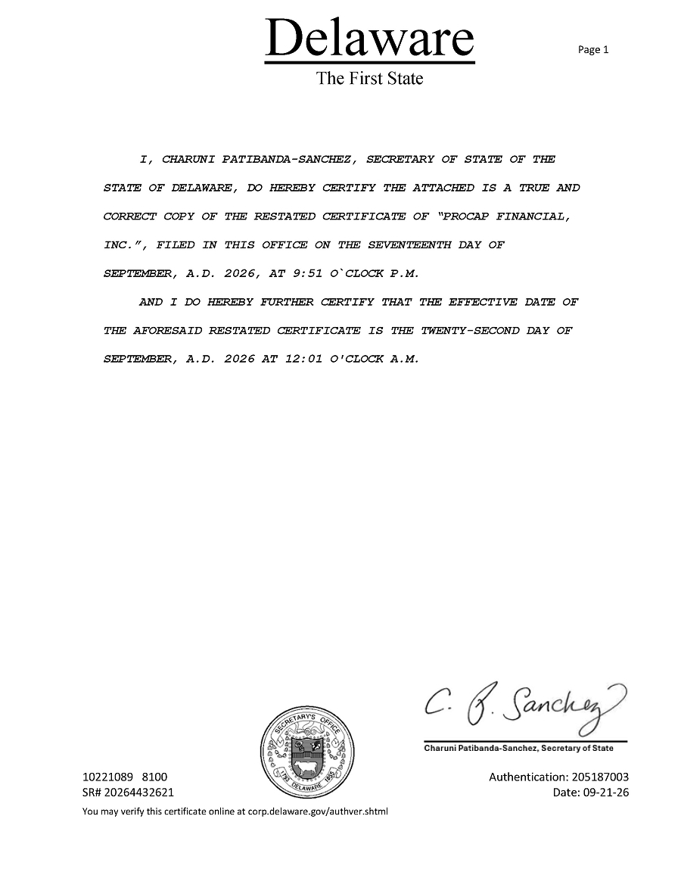

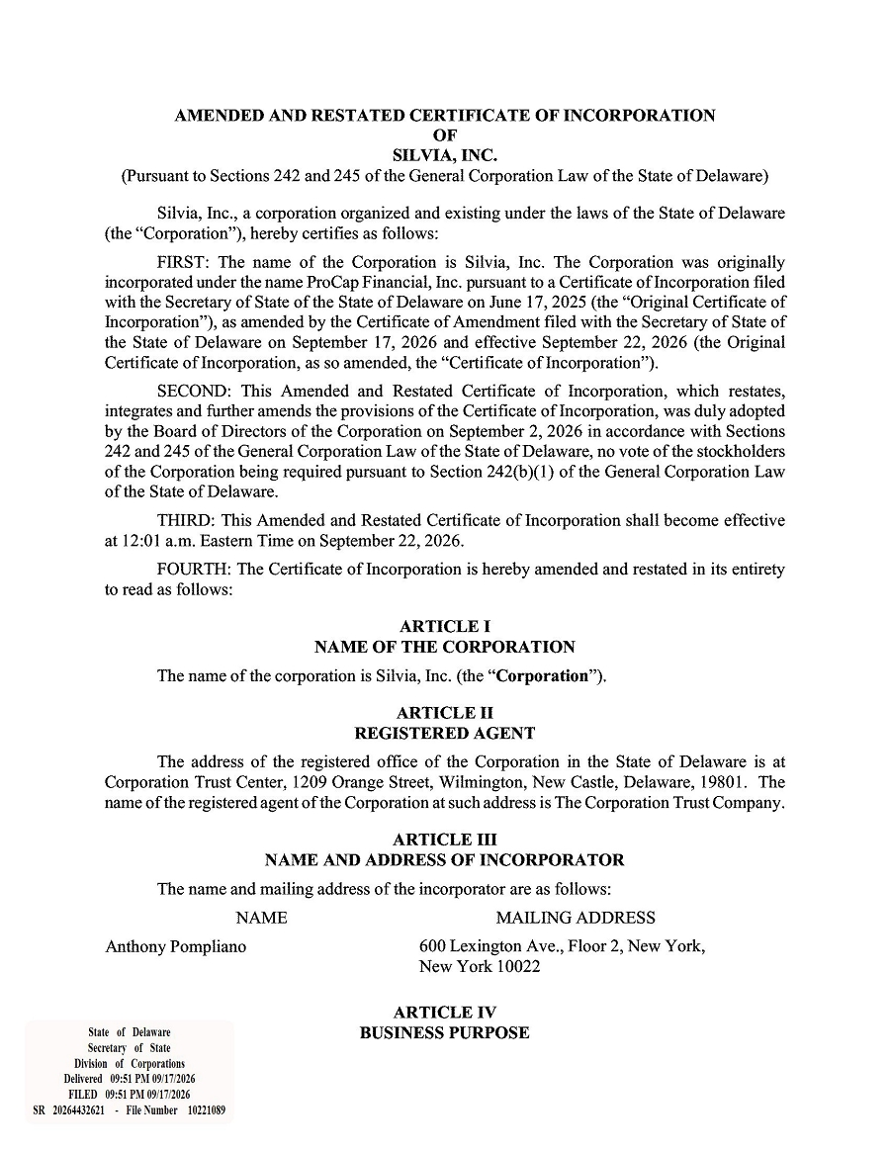

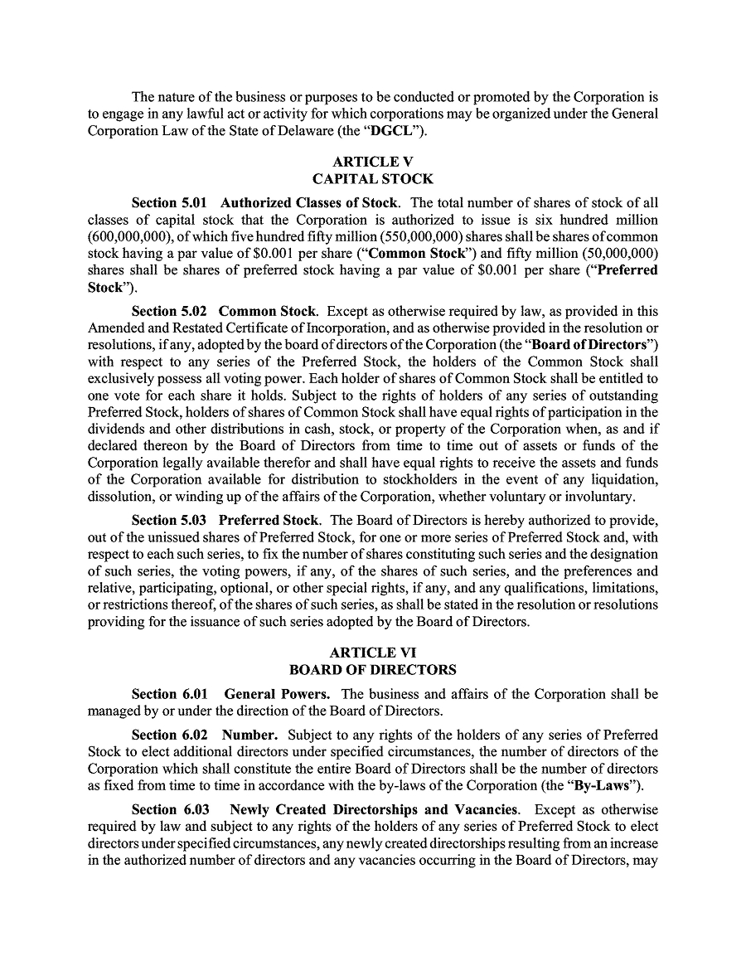

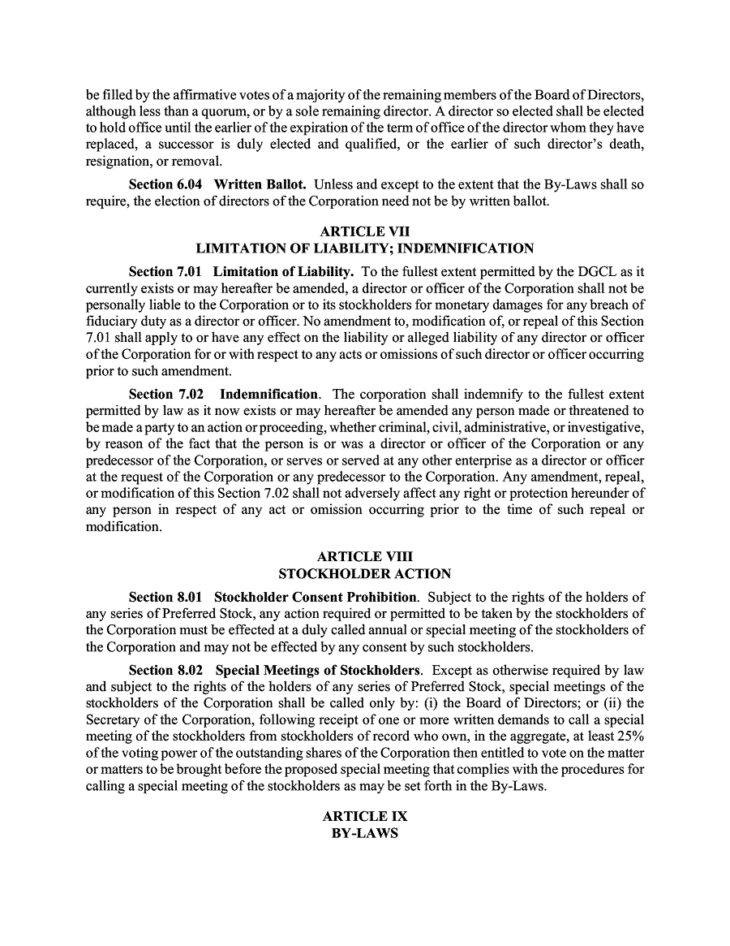

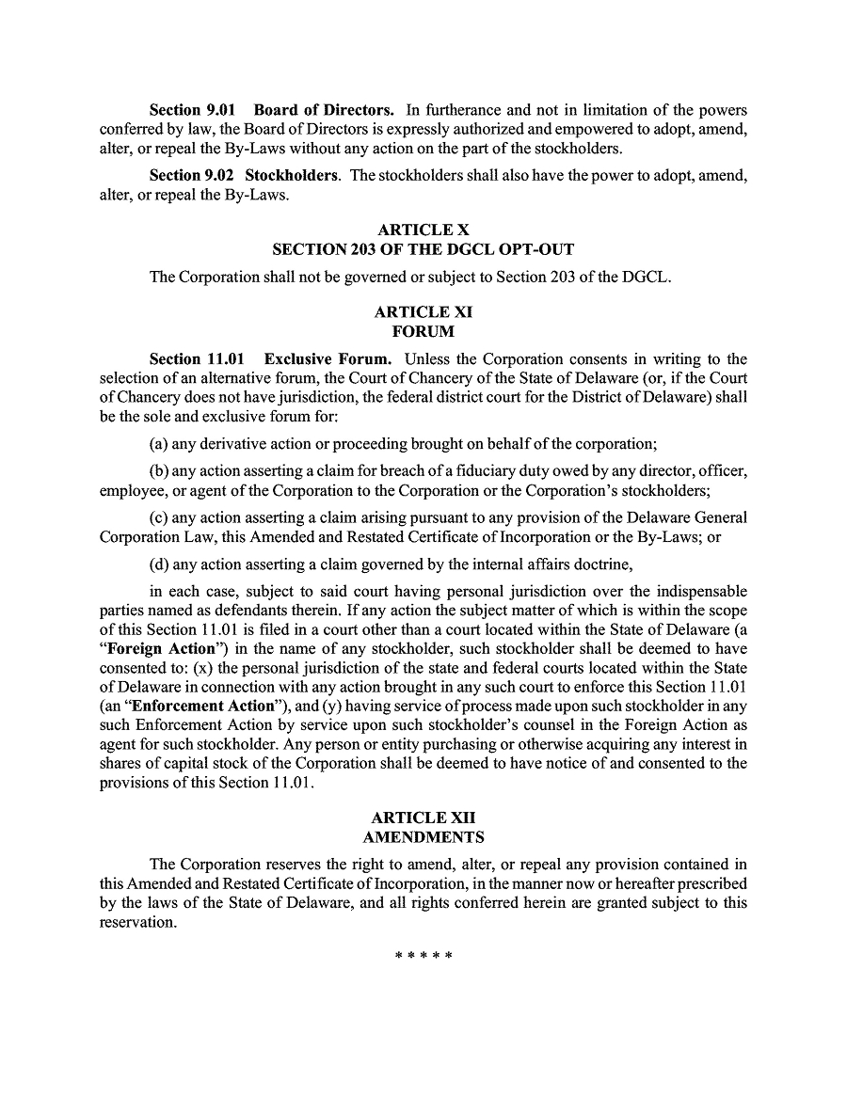

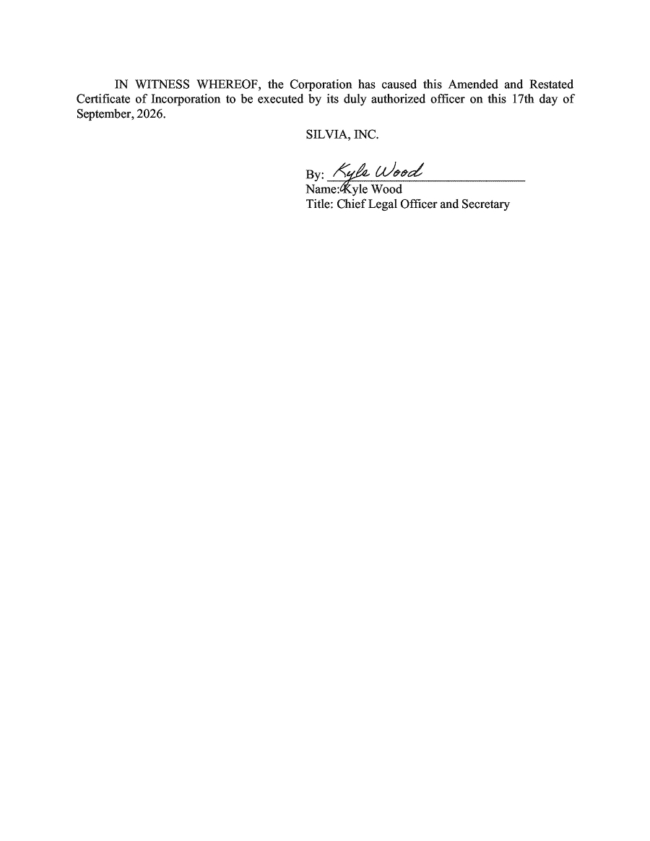

Exhibit 3.2

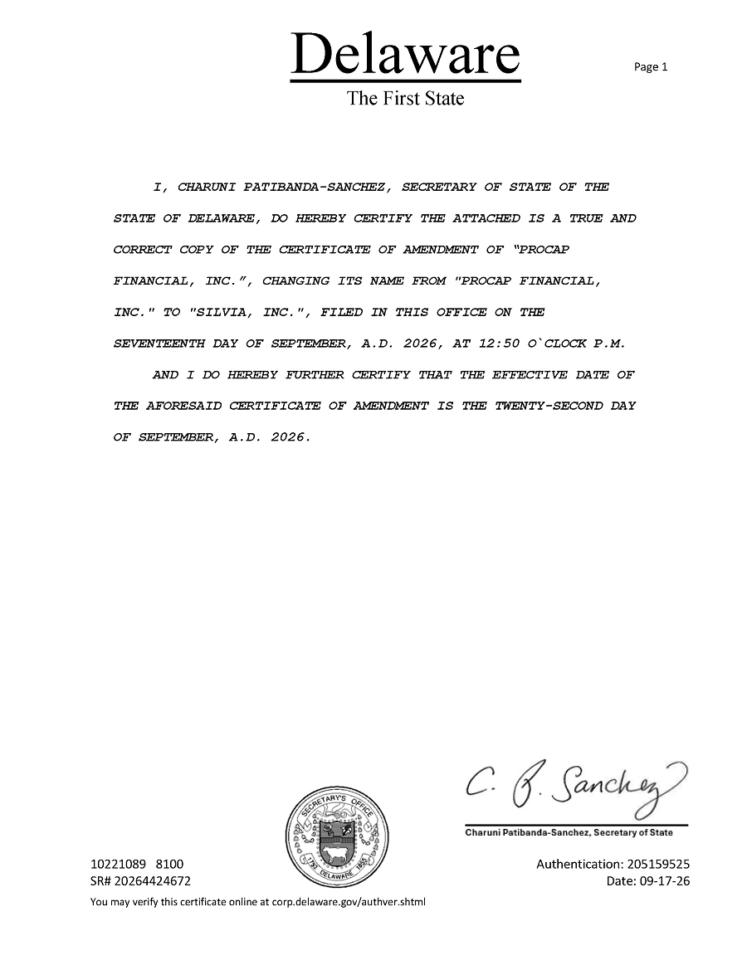

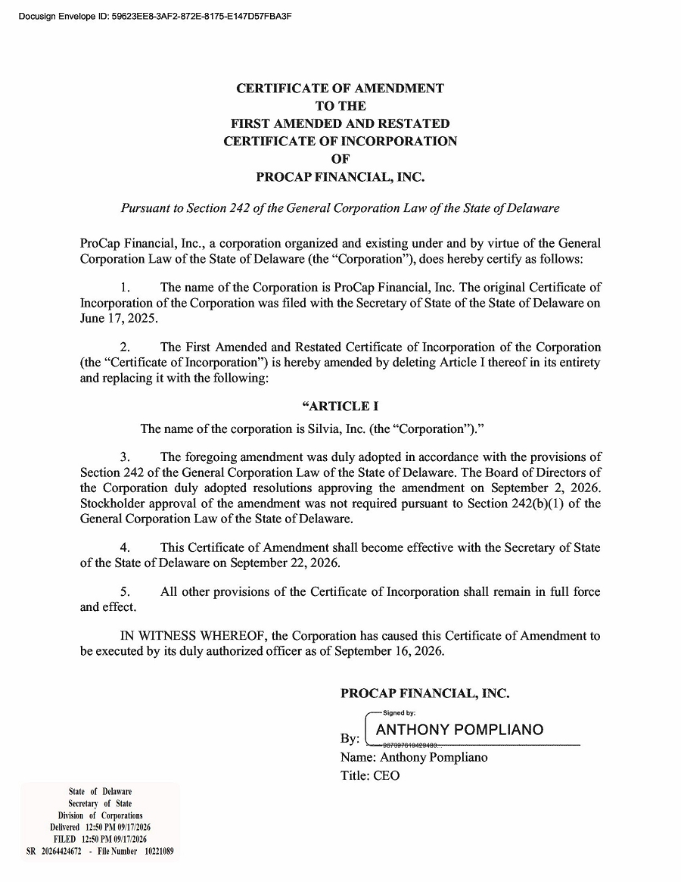

Exhibit 3.4

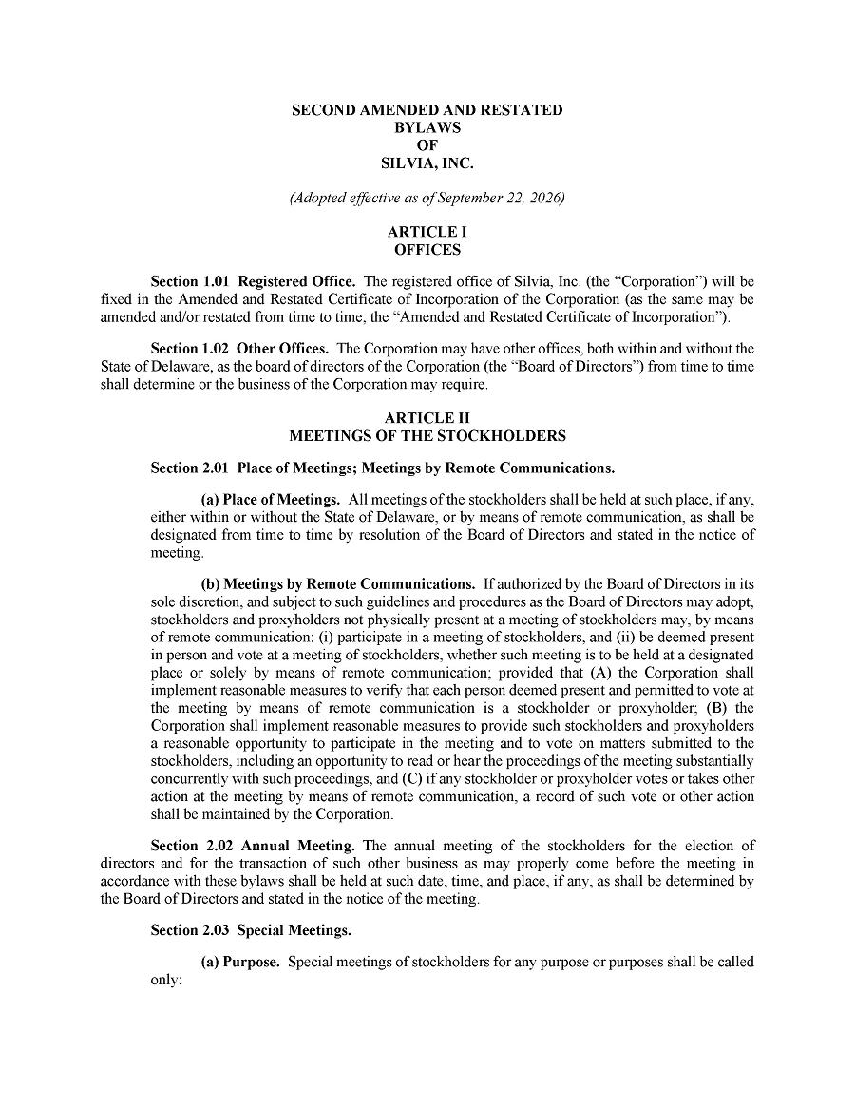

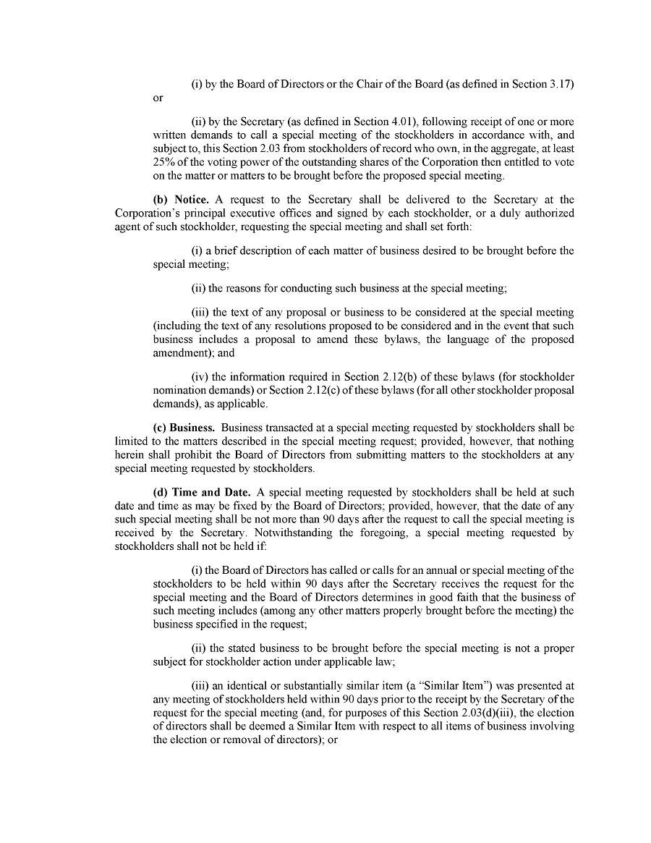

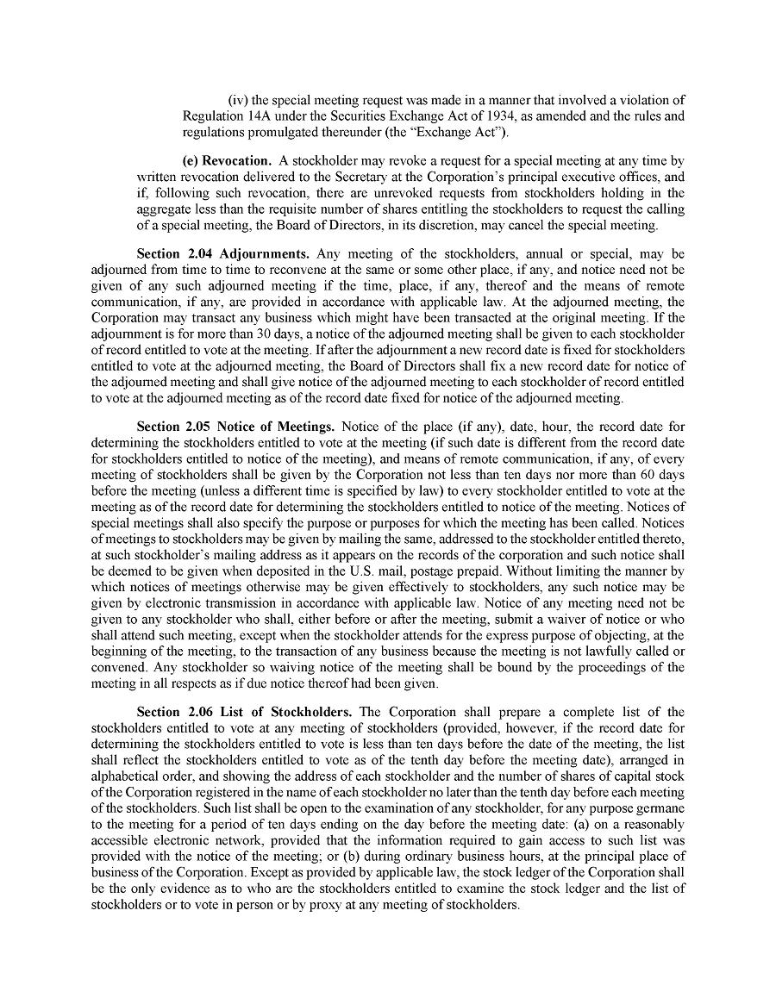

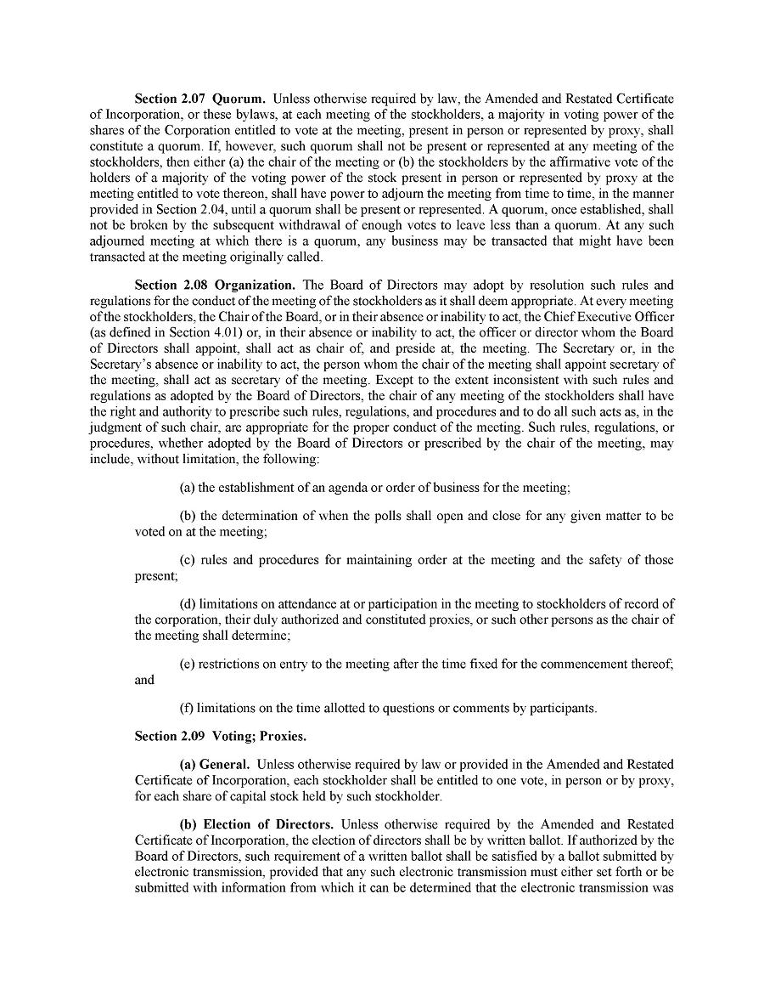

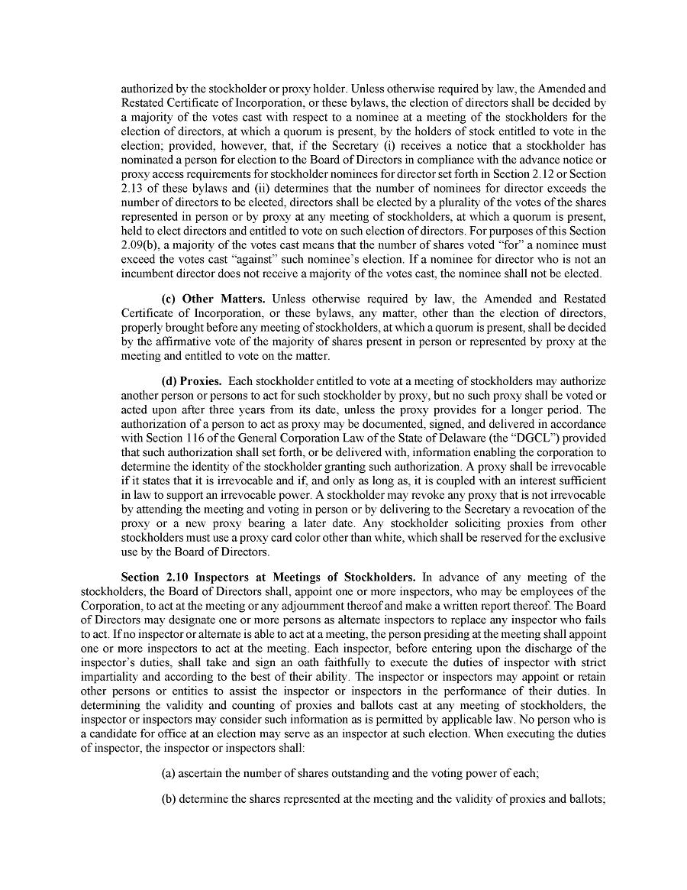

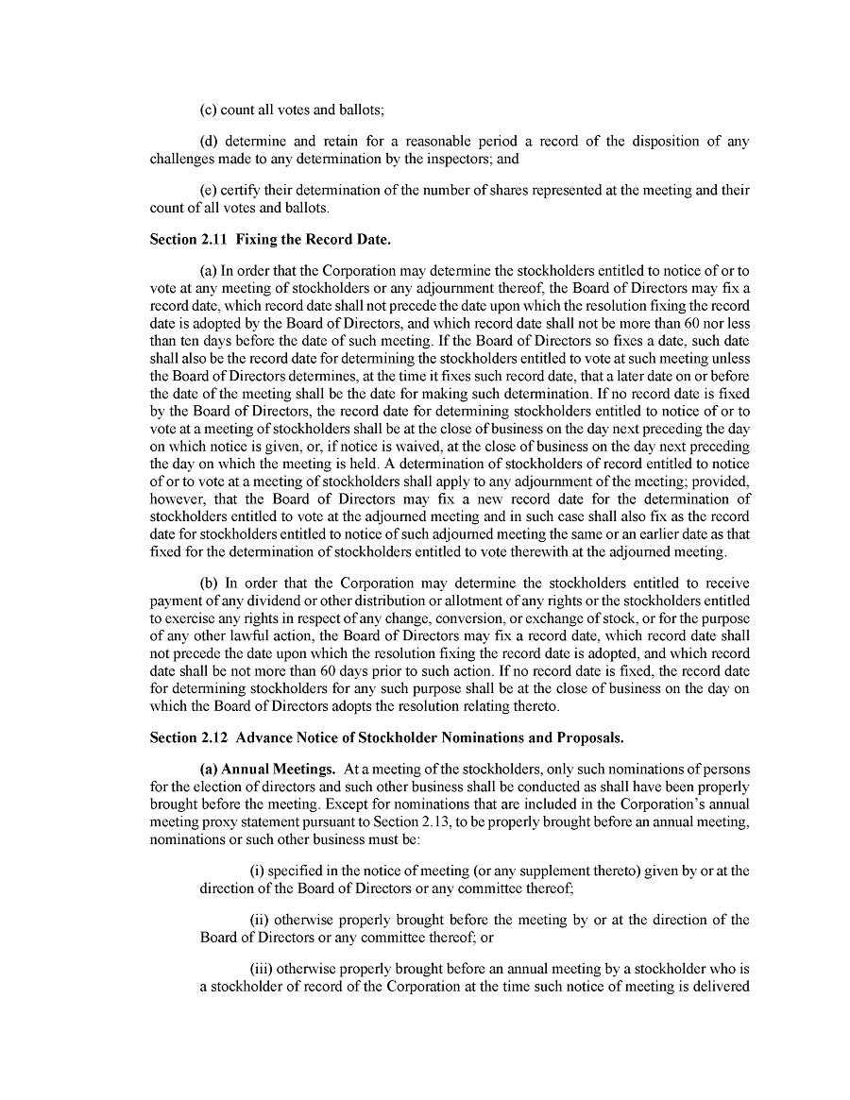

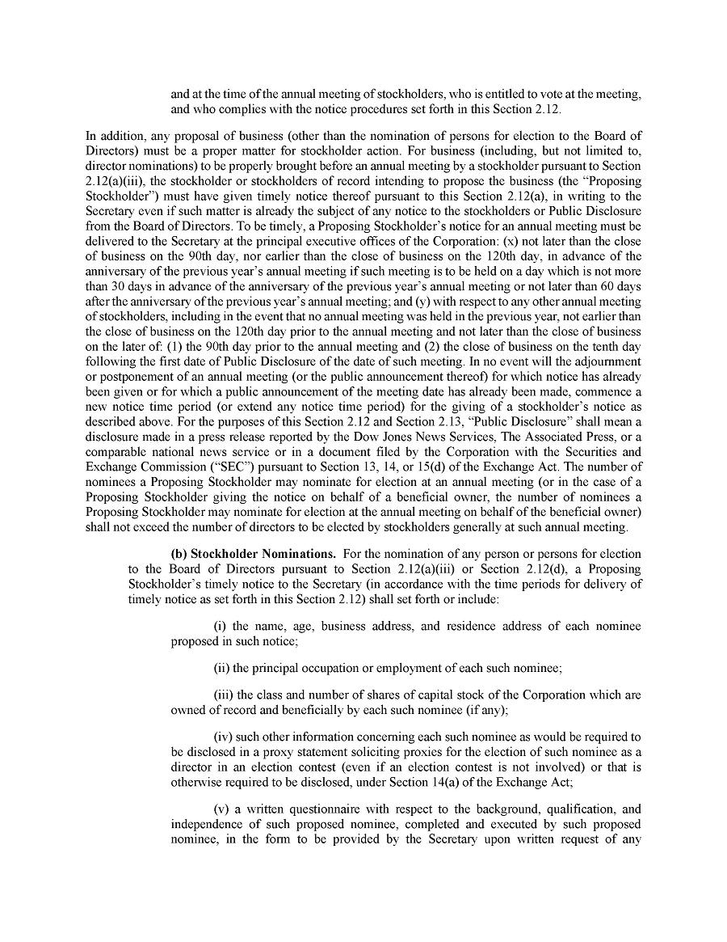

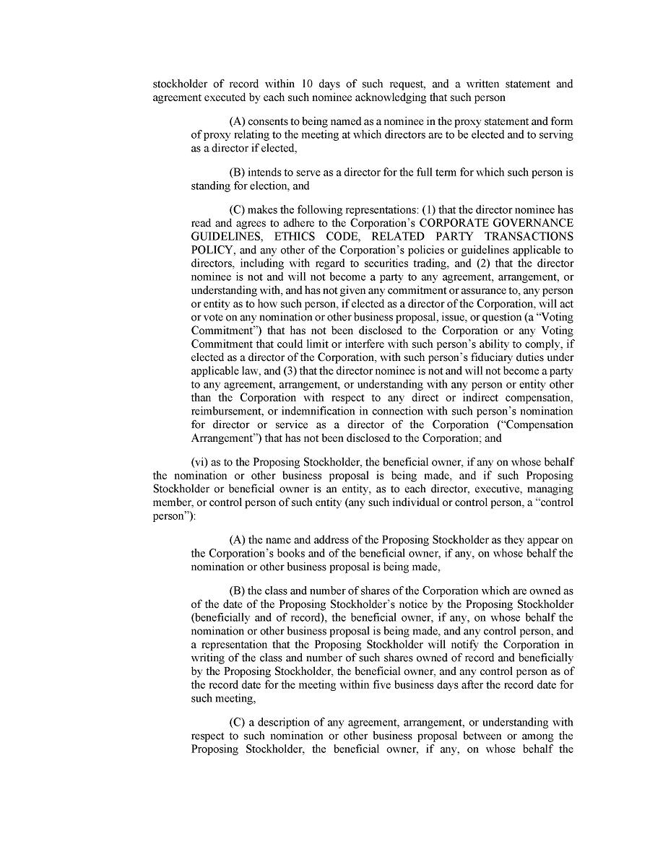

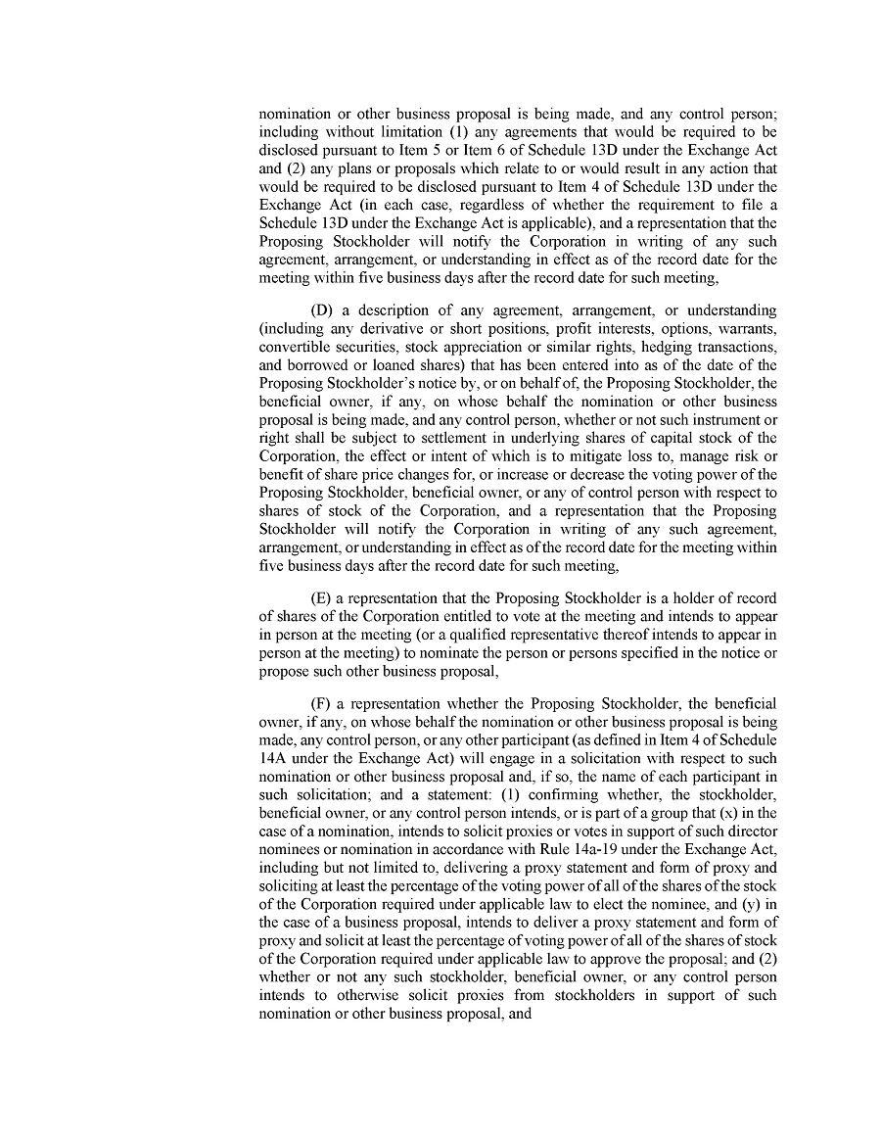

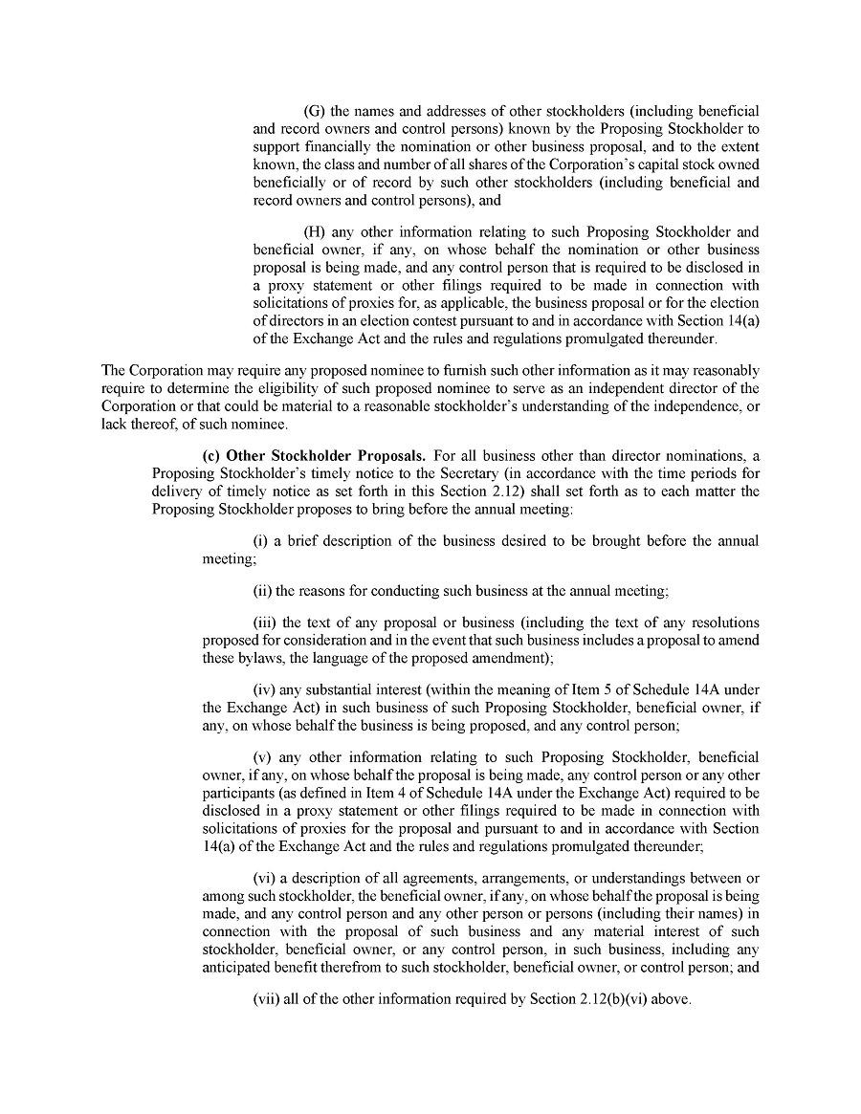

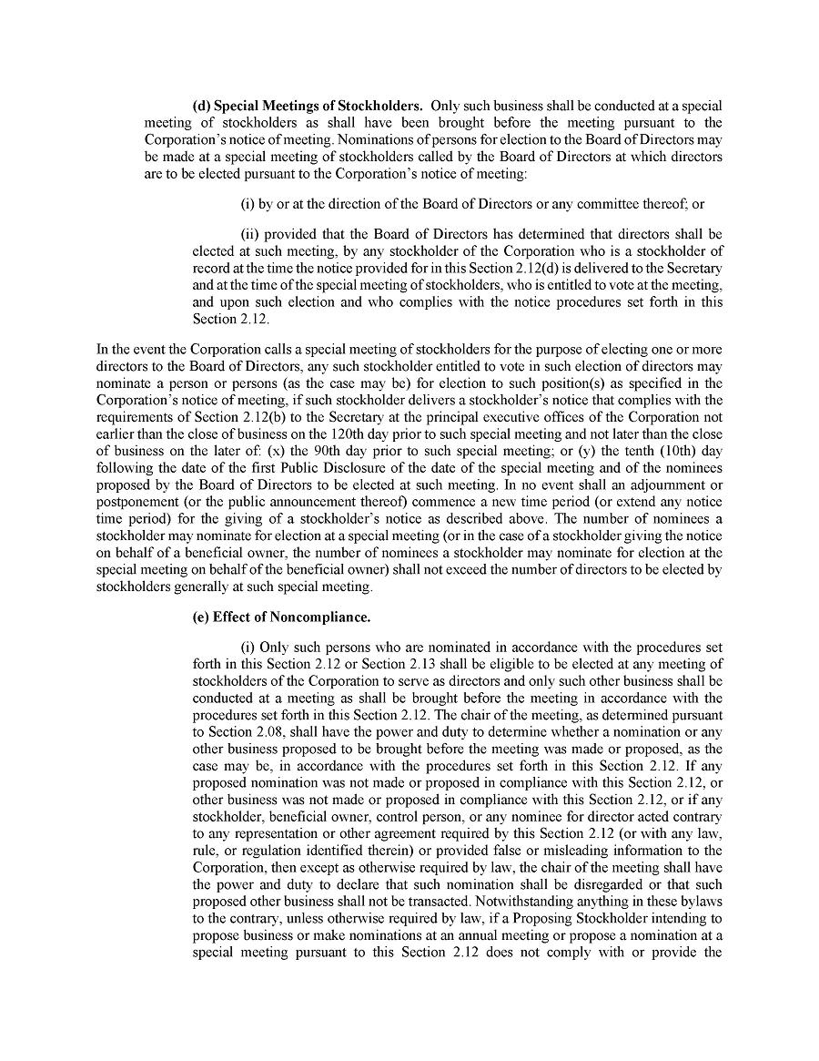

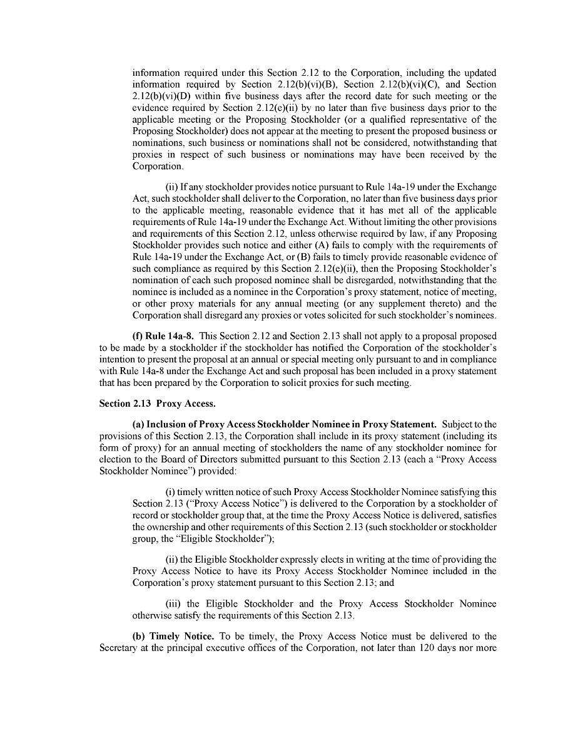

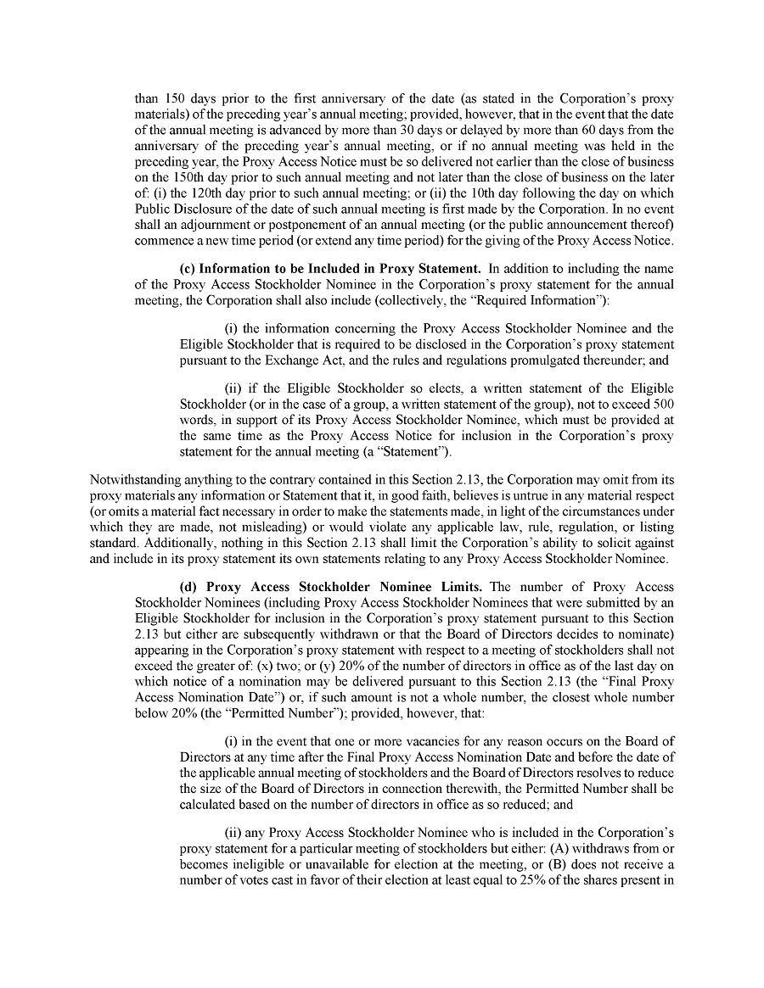

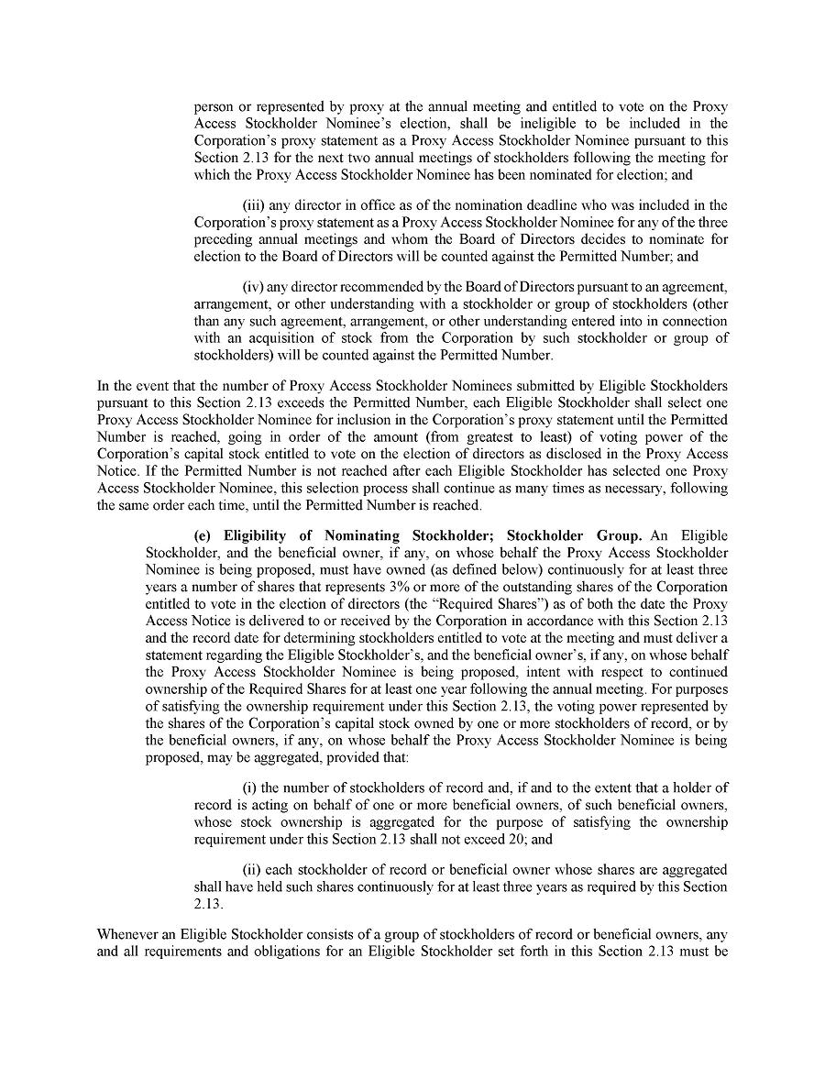

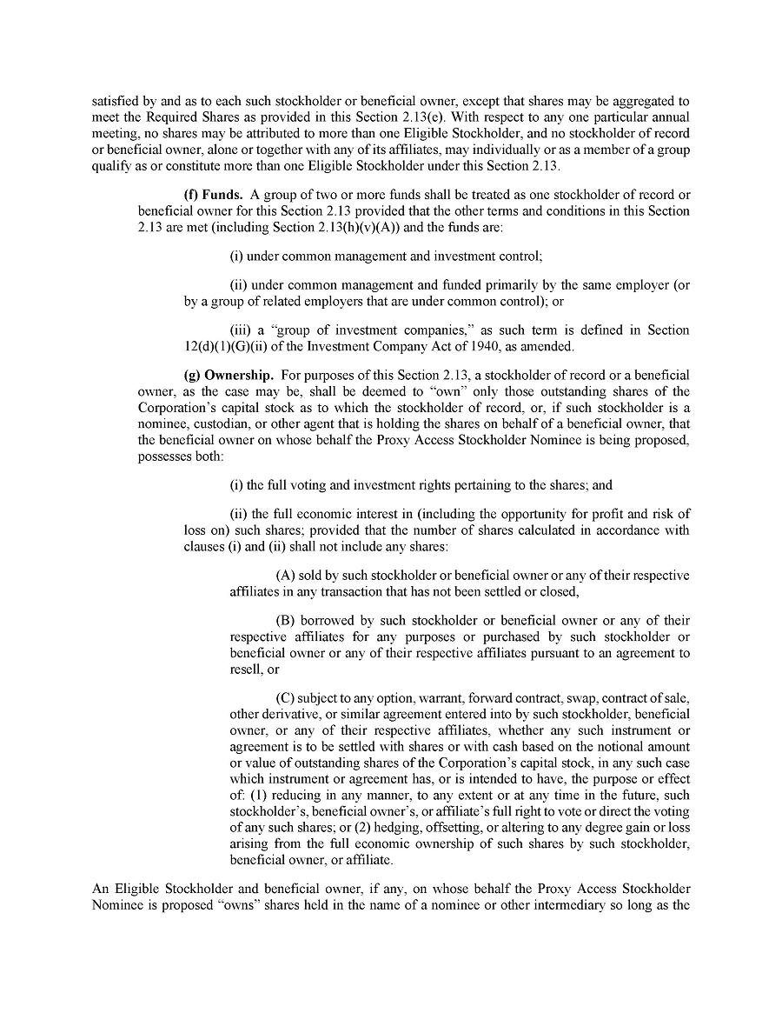

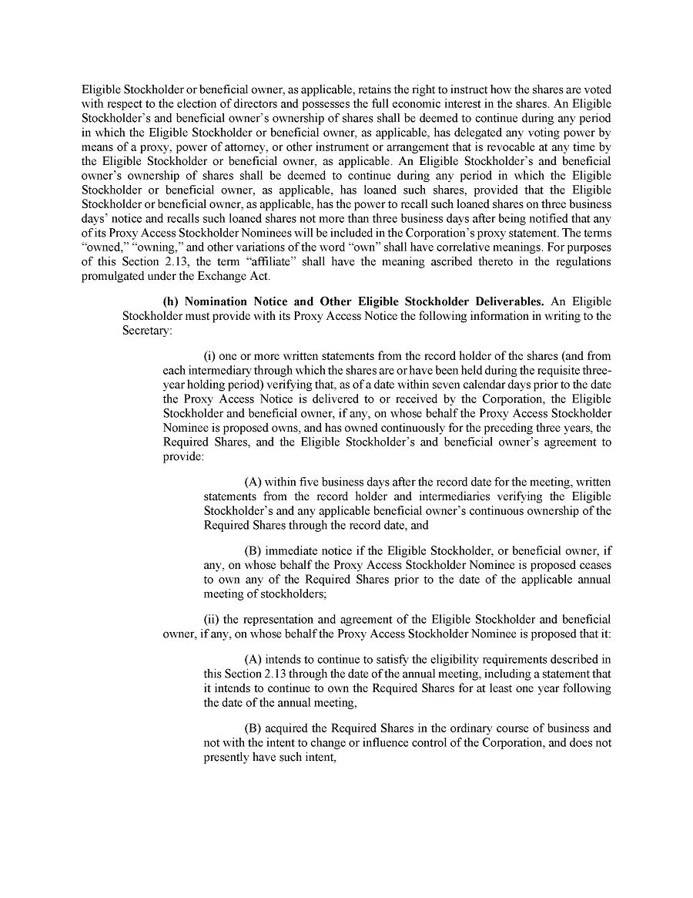

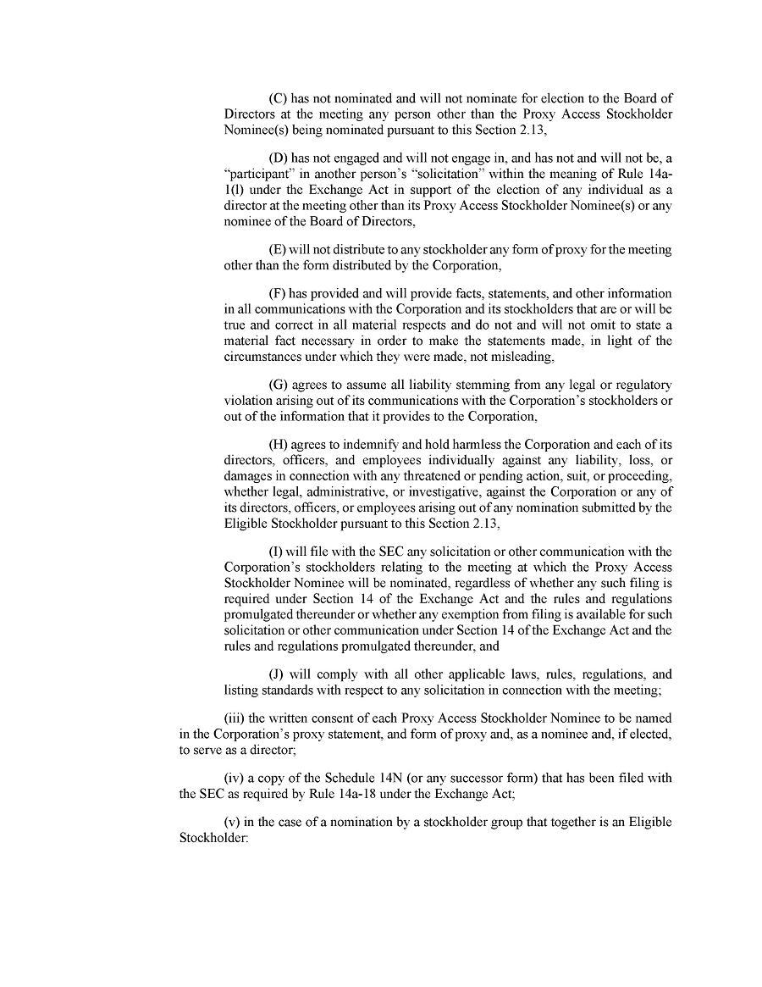

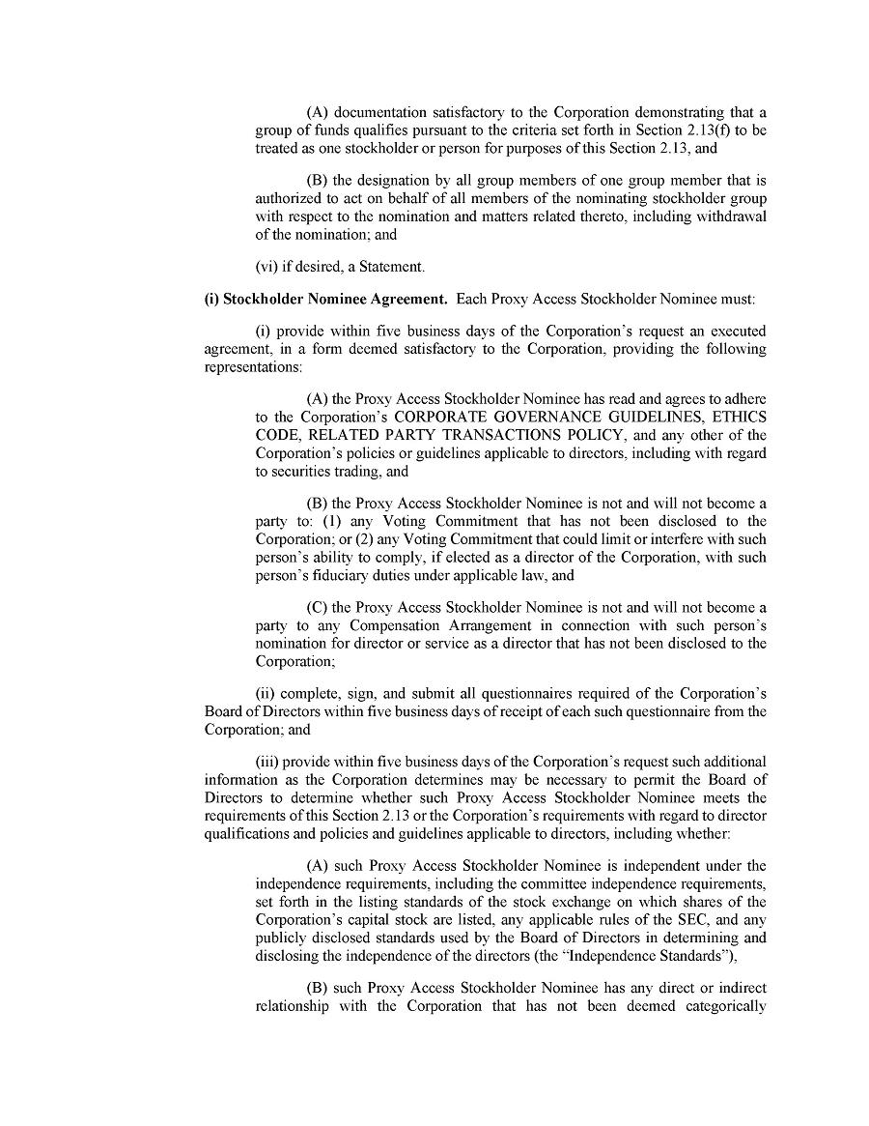

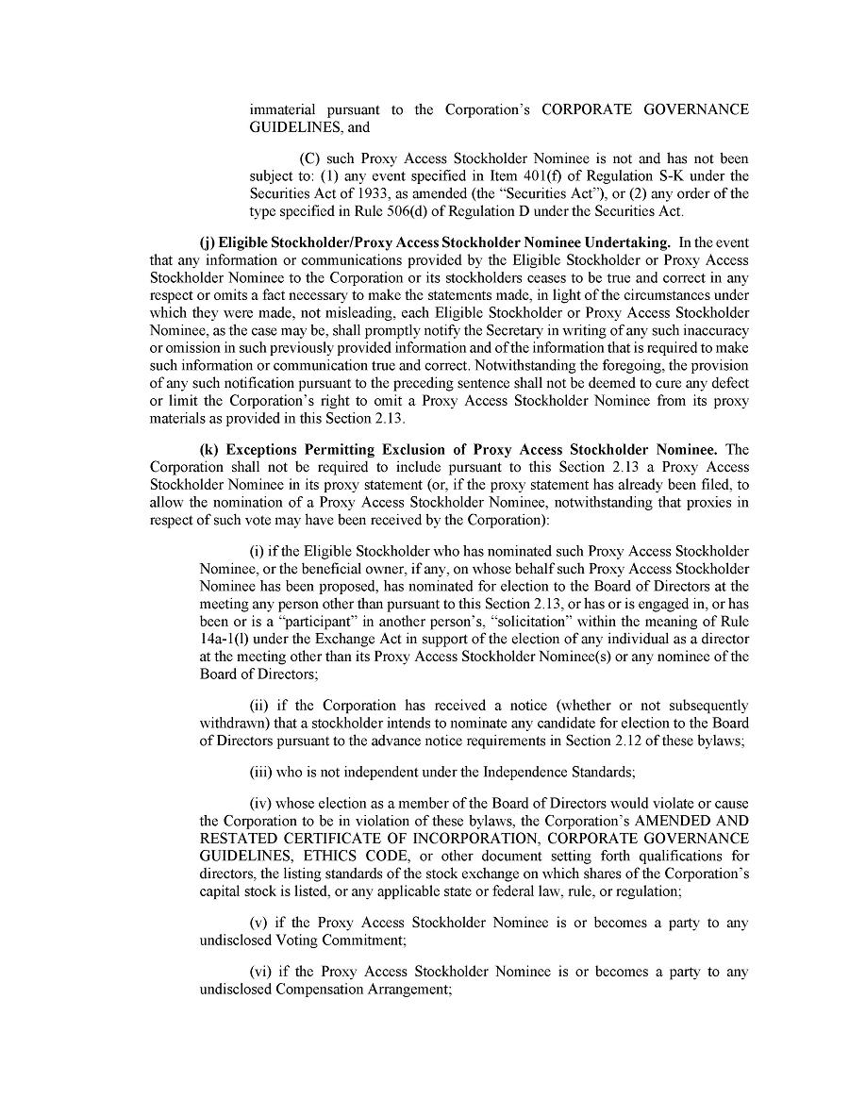

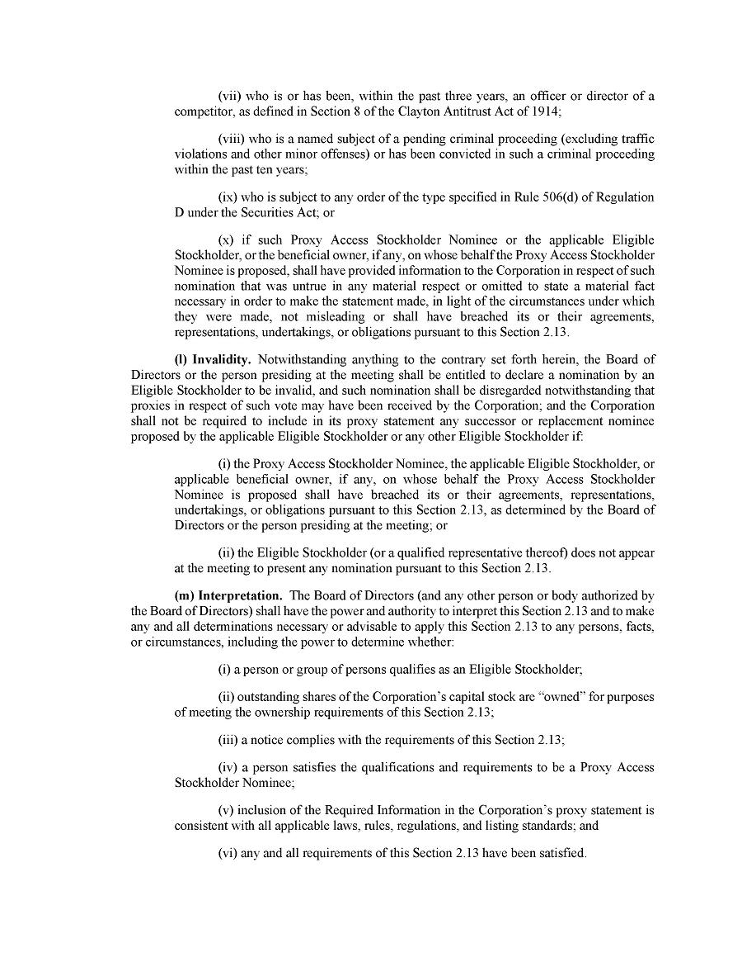

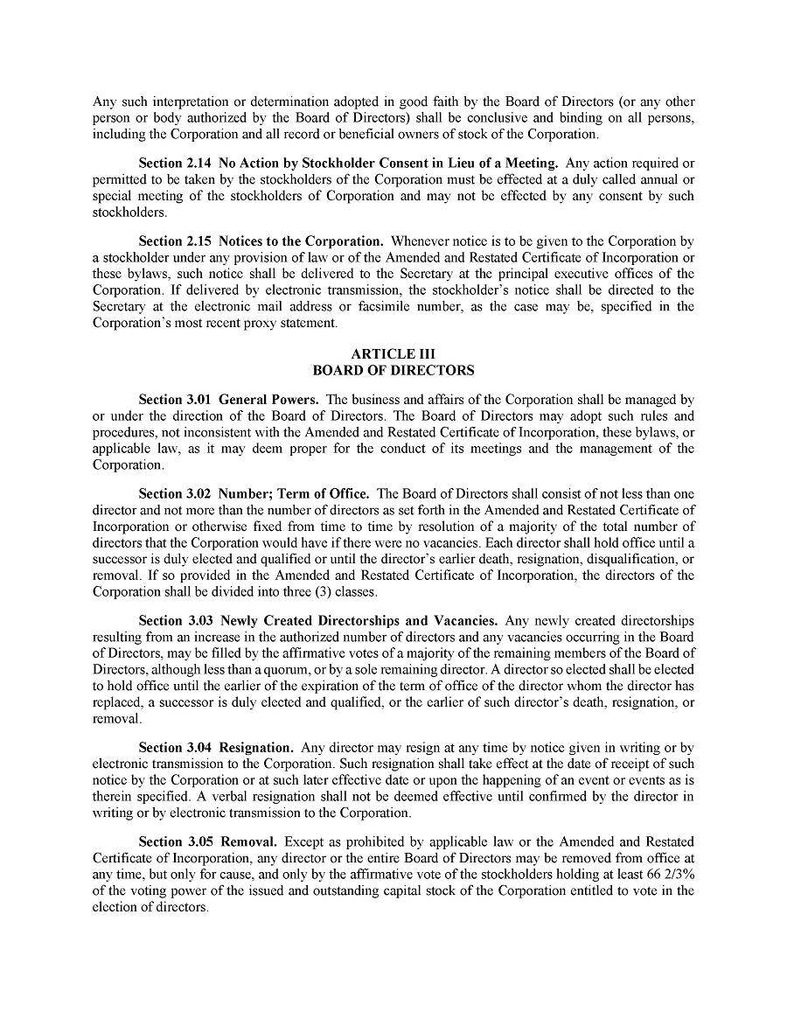

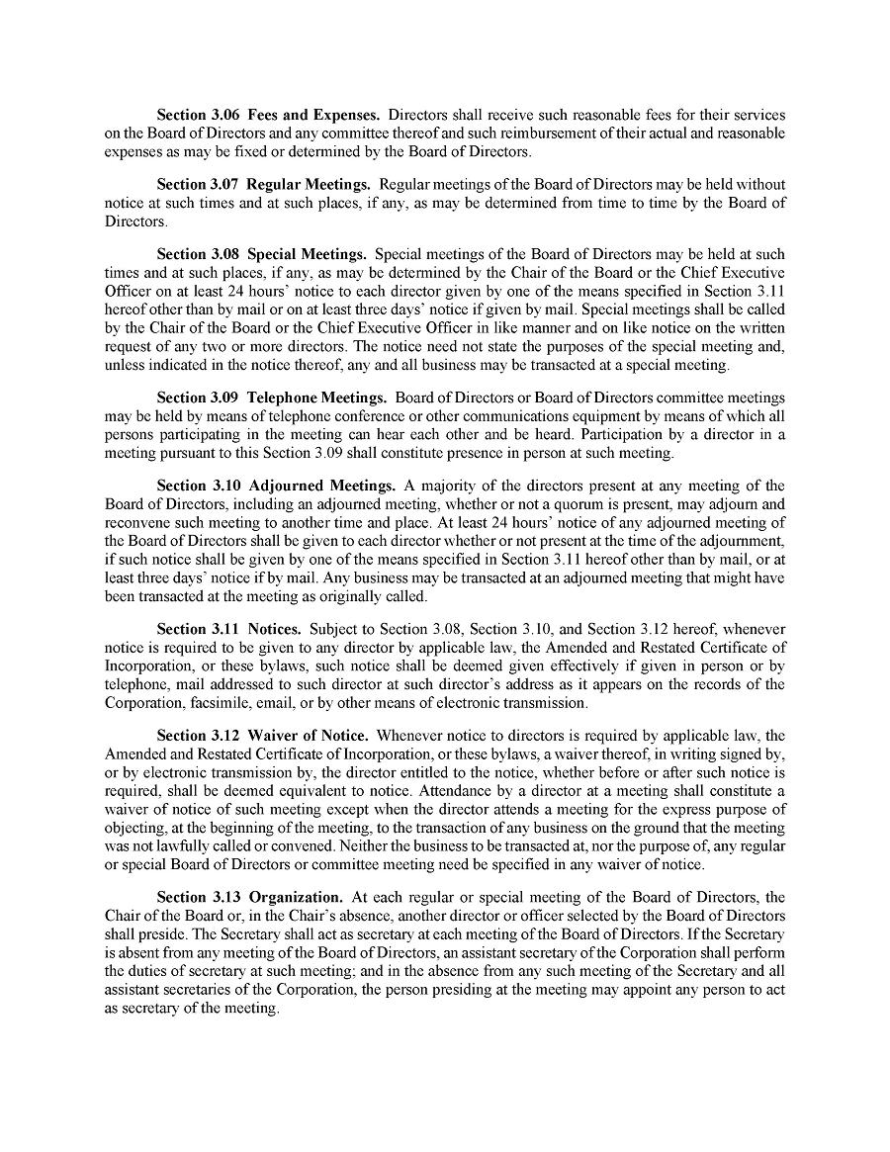

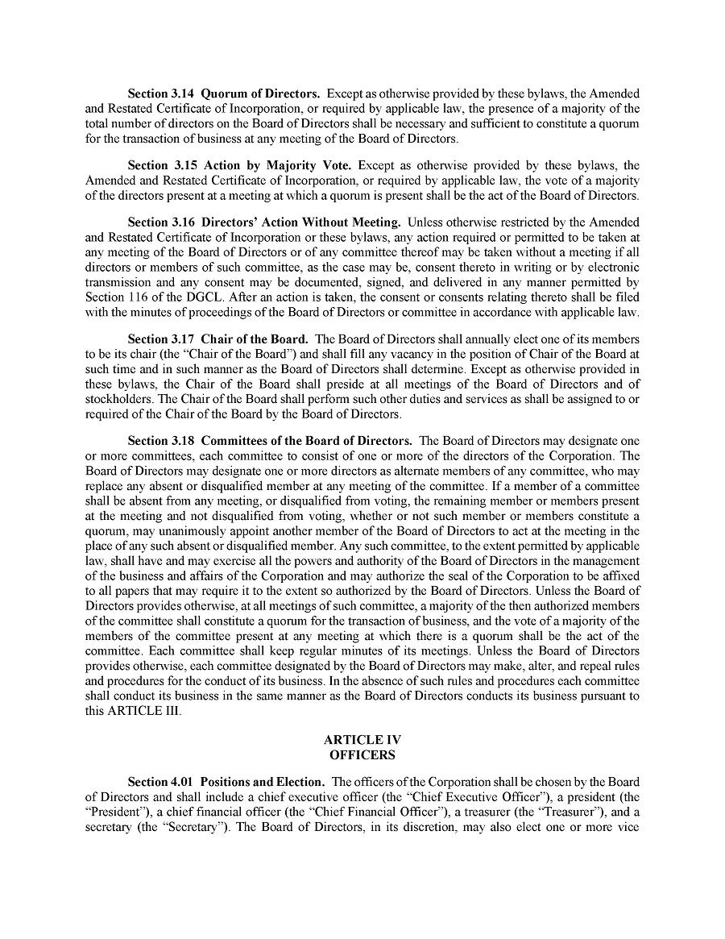

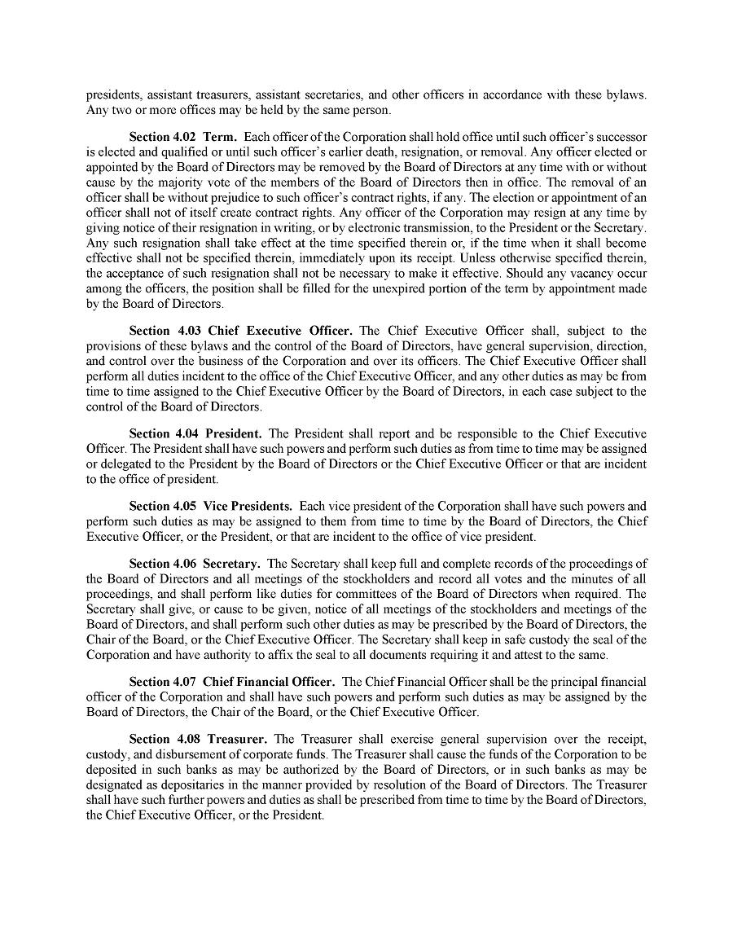

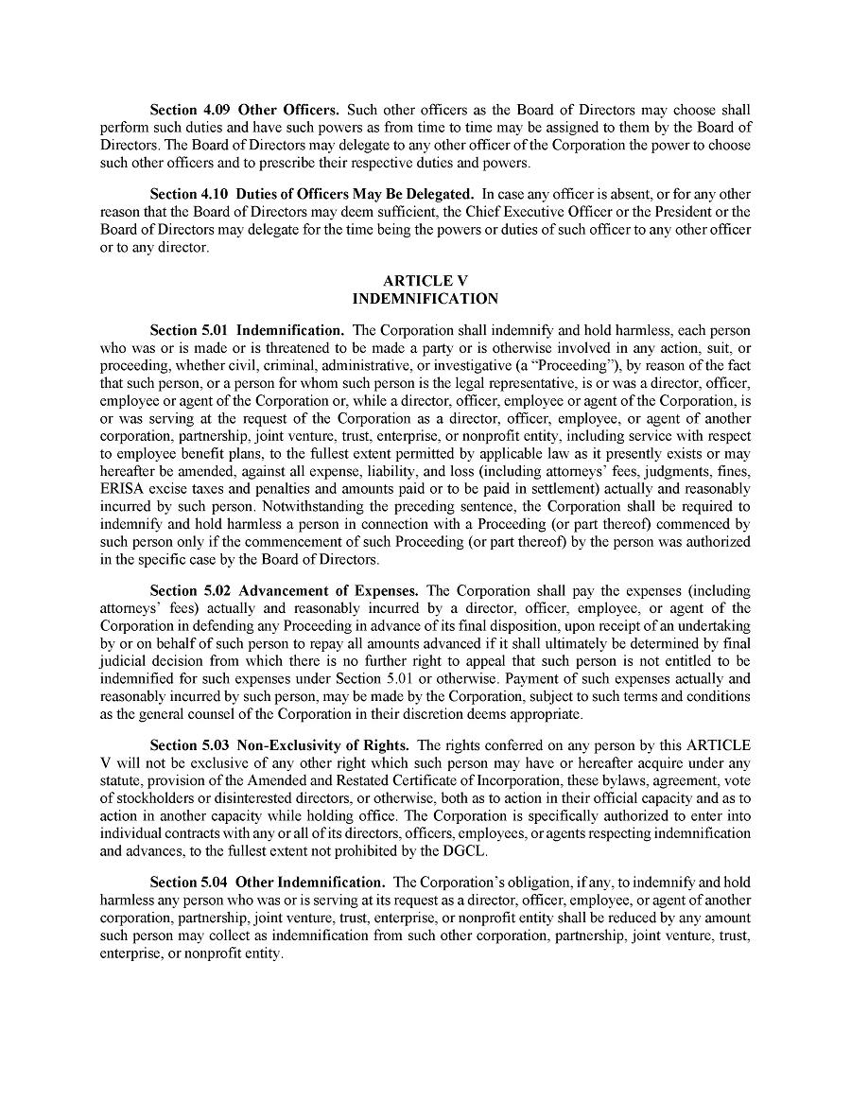

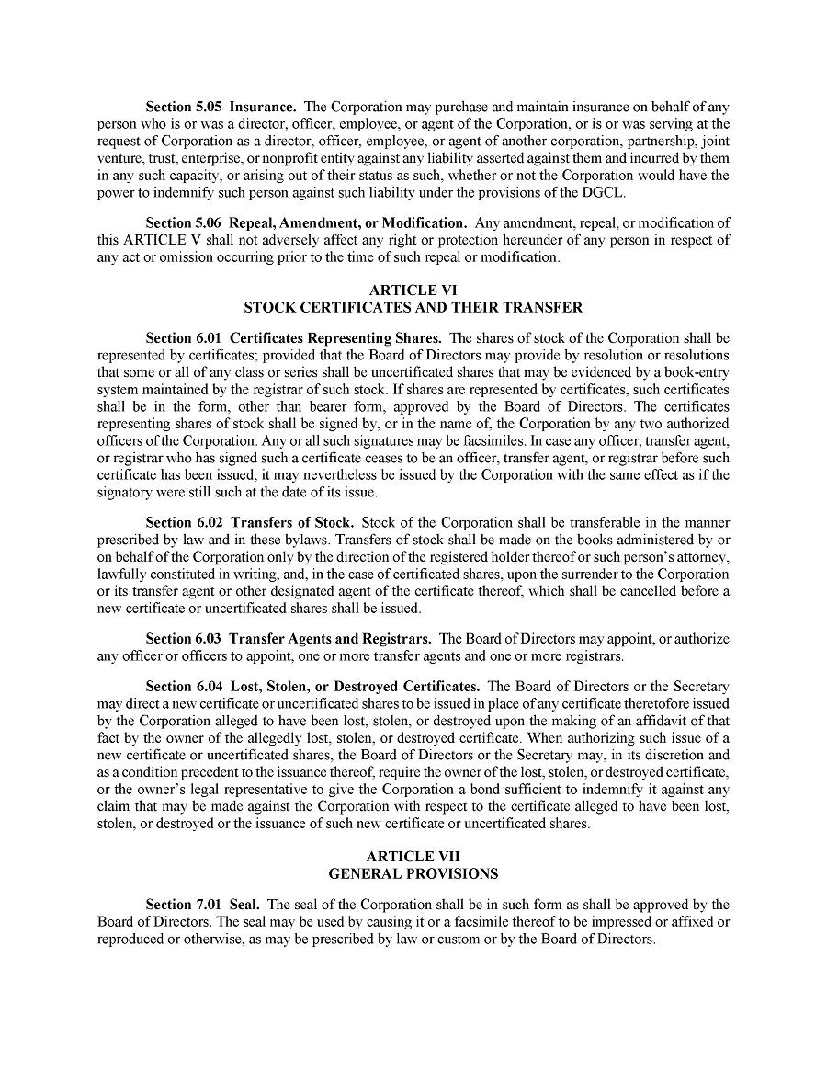

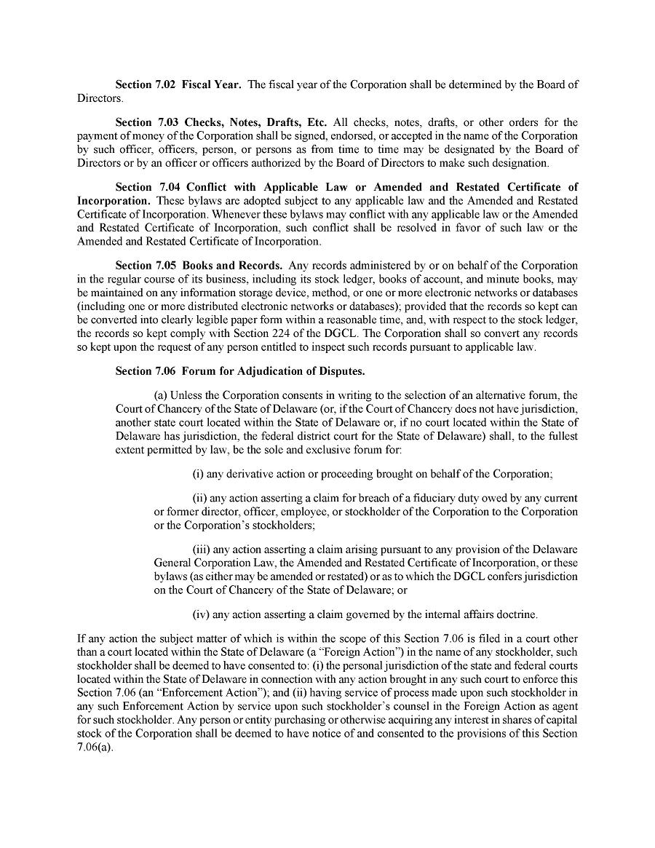

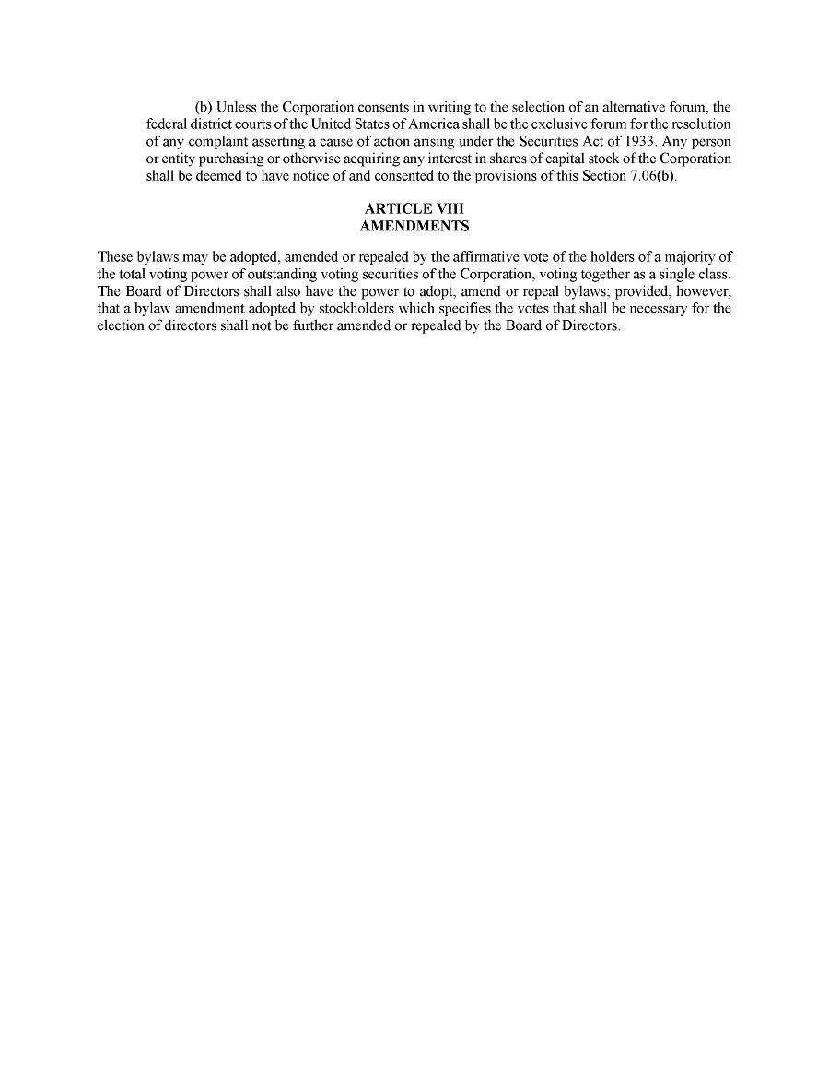

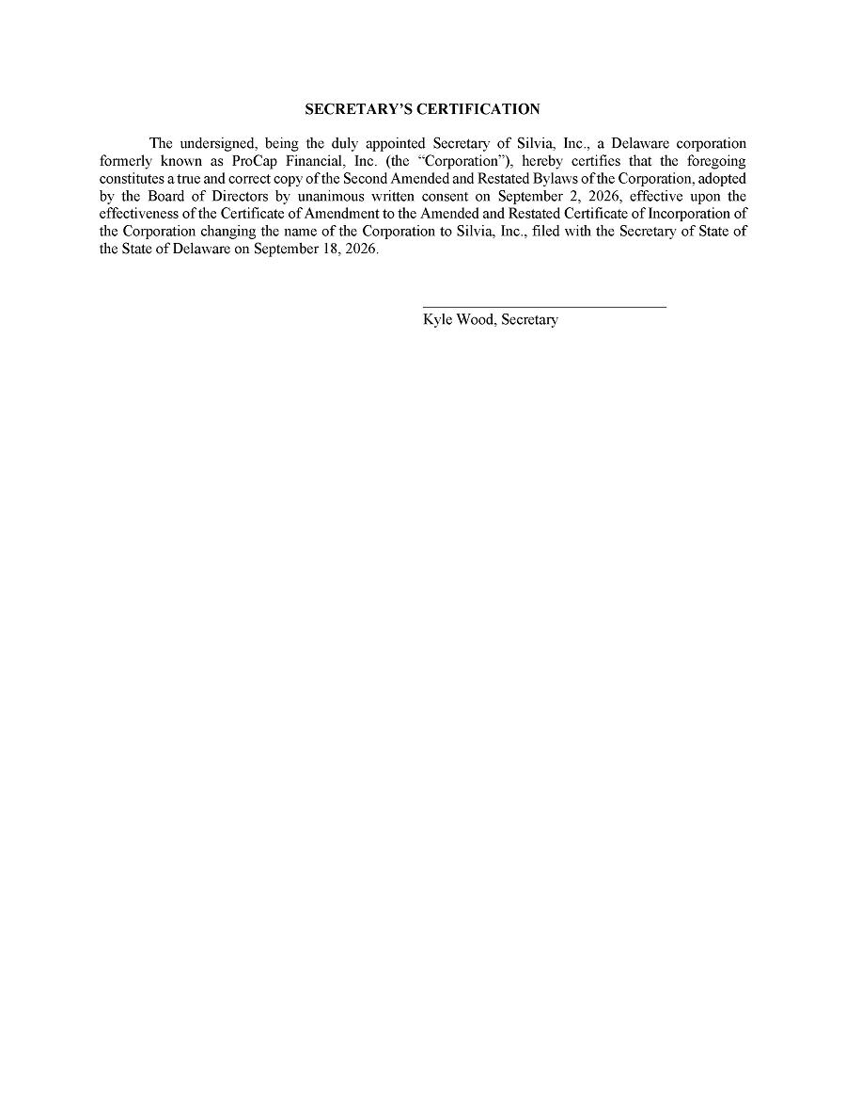

Exhibit 99.1



